 | FINAL EXAM PAPER  Quarter: 1 - Academic year: 2024 – 2025  School of Computing and Information Technology
Course code: CSE 203 |  | Exam code: 01
Course name: Object-oriented development |  | Duration: 120’
Type of Exam: Practice on Computer/ Open book |  | Maximum mark: 100
Instructions:
- Non-programming calculator: Yes ☐ | No ☒
- This paper consists of 1 section. This paper carries 100 marks.
Section 1 (100 marks) includes 2 work-out problem questions. Each question carries 50 marks.
------------------------------------------------------------------------------------------------------------------------------

Question 1: Simple Shipping Service (50 Marks)

Problem Description:
Design and implement a Simple Shipping Service for a logistics company. The service should handle shipping requests for packages and allow tracking of shipment statuses.

Requirements:
- Encapsulation:
  - Protect sensitive data such as tracking ID, sender/receiver information (names only), package weight and shipping status.
- Abstraction:
  - Create an abstract class ShippingService that defines common properties and methods for all shipping types.
- Inheritance:
  - Implement two types of shipping:
    - StandardShipping: cost = $5 base fee + $1 per kg.
    - ExpressShipping: cost = $10 base fee + $2 per kg.
- Polymorphism:
  - Demonstrate polymorphic behavior using an abstract method, calculateCost, which is implemented differently for each shipping type.

Demonstration Requirements:
- The service allows customers to create shipping requests with the following details:
  - trackingId, senderName, receiverName, status and packageWeight.
- Calculate the shipping cost based on the type of shipping service.
- Allow updates to the shipment's status (e.g., "Pending", "In Transit", "Delivered").

Example Usage:
- A customer creates a shipment using StandardShipping for a package weighing 5kg. The calculated cost is $10.
- Another customer uses ExpressShipping for a package weighing 2kg. The calculated cost is $14.

Marking Scheme:
Criterion | Marks
UML Diagram | 12
- Correct representation of classes and relationships | 5
- Use of abstract class and inheritance | 5
- Proper depiction of encapsulation and methods | 2
Implementation | 38
- Encapsulation: Private fields, getters, and setters used correctly | 8
- Abstraction: Abstract methods and class implementation | 8
- Inheritance: Proper use of inheritance for shipping types | 8
- Polymorphism: Overriding methods for cost calculation | 8
- Code correctness and execution | 6
Total | 50

Question 2: Payment System with Discount Strategy (50 Marks)

Problem Description:
Design and implement a Payment System for an online store that supports multiple payment methods and dynamic discount strategies.

Requirements:
- SOLID Principles:
  - The system should adhere to SOLID design principles, particularly Abstraction, Dependency Inversion Principle (DIP), and Open/Closed Principle (OCP).
- Payment Methods:
  - Use an interface PaymentMethod to define payment processing. Should use a void function for demonstrating only.
  - Implement two payment methods:
    - CreditCard: Processes payments through credit cards.
    - EWallet: Processes payments through an e-wallet.
- Discount Strategy with Design Pattern:
  - Use the Strategy Design Pattern to handle different discount strategies:
    - NoDiscount: No discount applied.
    - FixedDiscount: Applies a fixed discount (e.g., $10, the price after discount = original price - 10).
    - PercentageDiscount: Applies a percentage discount (e.g., 10%).
- Operations:
  - For simplicity, the Order class should have necessary fields (id, cost, payment method, and discount strategy)
  - The Order class should allow:
    - Setting a payment method.
    - Setting a discount strategy.
    - Calculating the final cost after applying the discount.
    - Processing payment using the selected payment method.

Example Usage:
- A customer places an order for $100, applies a Fixed Discount of $10 and pays using a Credit Card.
- Another customer places an order for $200, applies a 10% Percentage Discount, and pays using EWallet.

Marking Scheme:
Criterion | Marks
UML Diagram | 12
- Correct representation of design pattern | 5
- Clear depiction of relationships | 5
- Accurate use of interface and abstraction | 2
Implementation | 38
- Encapsulation: Properly encapsulates order details | 10
- Abstraction: Interface PaymentMethod used correctly | 8
- DIP: Order depends on abstraction for payment | 8
- Strategy Pattern: Implements discount strategy | 6
- Code correctness and execution | 6
Total | 50

Submission Instructions
- Submit your source code files.
- Provide a document containing UML diagrams for each question (hand-drawn and scanned diagrams are acceptable).
- Ensure your code is well-documented and properly formatted.

Solution:
Question 1:
- UML:
Students should have 3 classes named ShippingService, StandardShipping and ExpressShipping. The ShippingService class must be an abstract one containing an abstract method named calculateCost. The ShippingService class should have attributes for containing information including id, sender name, receiver name, package weight and status. Students should also express the relationship (inheritance) between classes. The subclasses must at least implement the calculateCost method. The following UML can be used as a reference for marking:
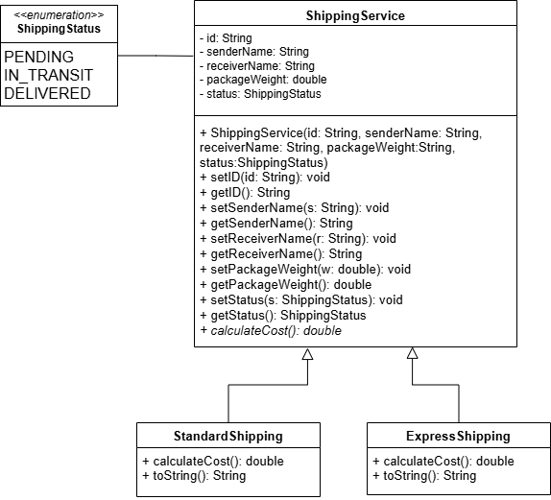
- Implementation:
  - Students must use class names exactly as required, can change the field names but should be self-descriptive and have appropriate data types. The shippingStatus attribute’s data type can be String. The classes must have all methods serving the required functionalities of the simple shipping app and relationships as stated in the UML.
  - In the demonstration, students must create objects of StandardShipping and ExpressShipping classes, update shipping status, and display the details of the shipping services. The objects should be referenced by a ShippingService variable.
  - Code correctness:
    - Use right naming conventions for classes, methods, constants, and variables
    - Use right indentations for codes
Question 2:
- UML:
Students should have a class named Order. The Order class must use interfaces as attributes for payment method and discount strategy and other attributes for storing the cost and the id of the order. The concrete classes for payment methods and discount strategies should be included in the UML as well. The relationships (association, implement) must be expressed in the UML using appropriate arrows. All the classes must have enough attributes and method as required. The following UML can be used as a reference for marking:
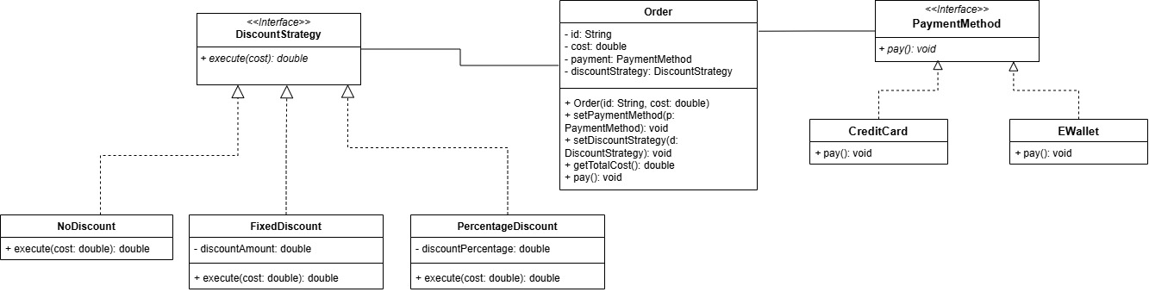
- Implementation:
- Students must use class names exactly as required, can change the field names but should be self-descriptive and have appropriate data types.
- The classes must have all methods serving the required functionalities of the simple ordering app and relationships as stated in the UML
- For the demonstration, students must create different orders, apply at least two discount strategies and use at least two different payment methods.
- Code correctness:
  - Use right naming conventions for classes, methods, constants, and variables
  - Use right indentations for codes

------ End ------
Lecturer’s signature

